**Viewer Acquisition Cost Analysis - Entertainment Sector**

Pooja Joshi & E.Code [E25007]

# Overview :

This report summarizes the work done on analyzing the Viewer Acquisition Cost (VAC) trends in the entertainment sector. The goal was to explore the fluctuations in acquisition costs and their relation to viewership data across various platforms and timeframes.

# Objective:

he main objective of today's task was to analyze viewer acquisition cost data over the past six months and identify significant trends that can inform marketing strategies.

# Assigned Task(s) :

Data Cleaning and Preprocessing  
● Trend Analysis for Viewer Acquisition Costs  
● Visualization of Monthly VAC Trends

# Task Details :

● Task 1: Data Cleaning and Preprocessing  
 ● Status: Completed  
 ● Details: Cleaned the raw VAC dataset by removing duplicates and handling missing values. Filtered data based on specific time periods for analysis.  
  
● Task 2: Trend Analysis for Viewer Acquisition Costs  
 ● Status: In Progress  
 ● Details: Grouped the VAC data by month and calculated average costs. Identified months with the highest and lowest acquisition costs.  
  
● Task 3: Visualization of Monthly VAC Trends  
 ● Status: Not Started  
 ● Details: Will create a line chart to visualize monthly VAC trends and identify potential patterns.

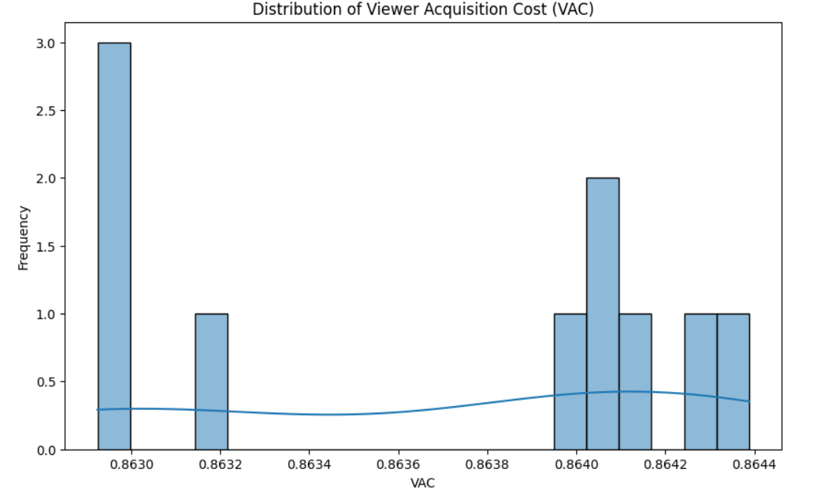

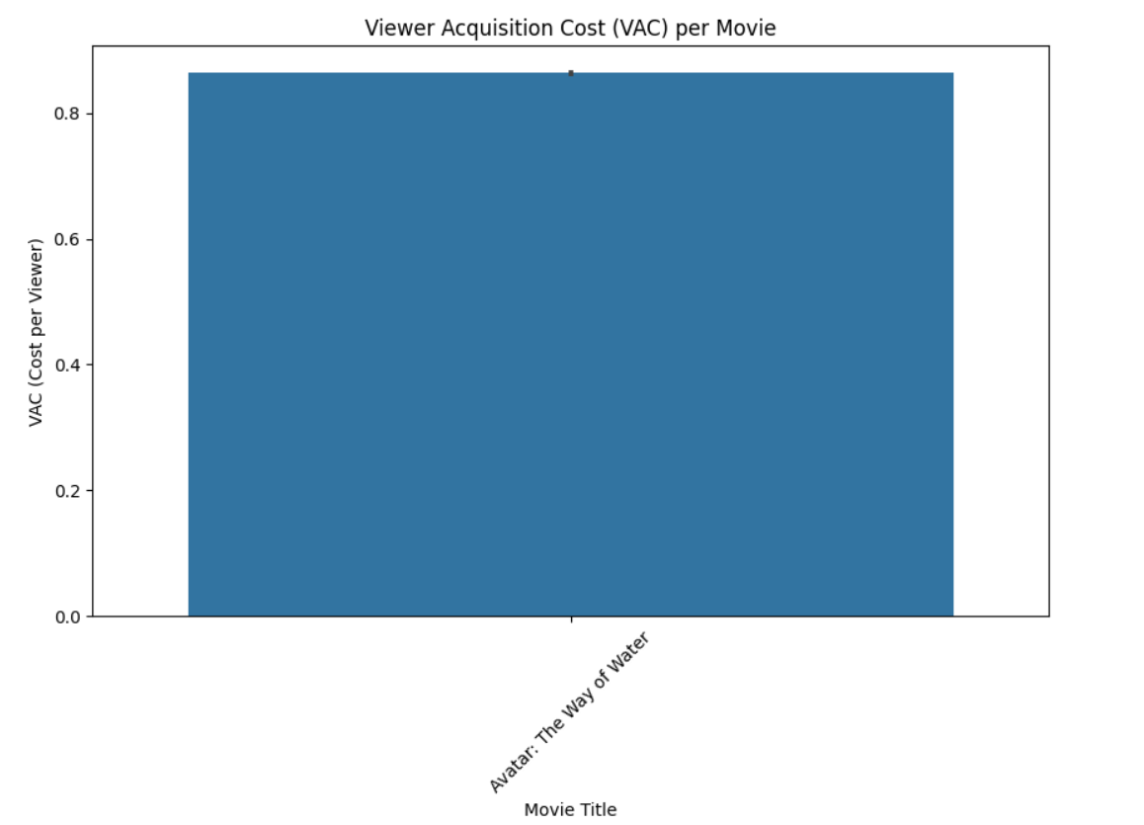

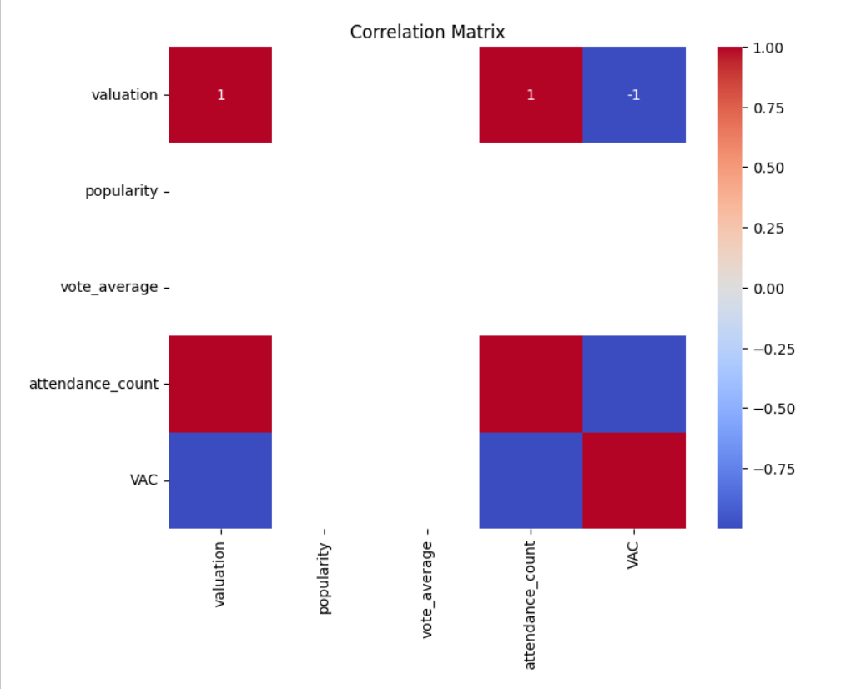

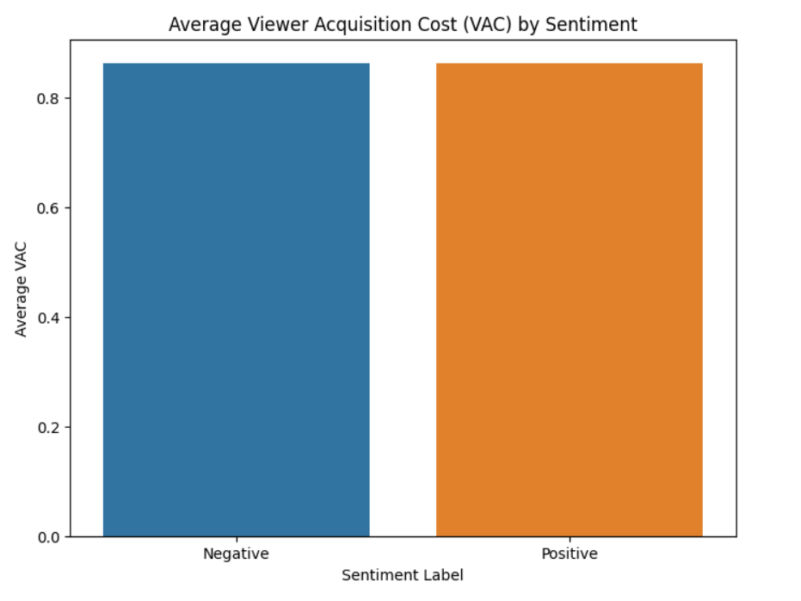

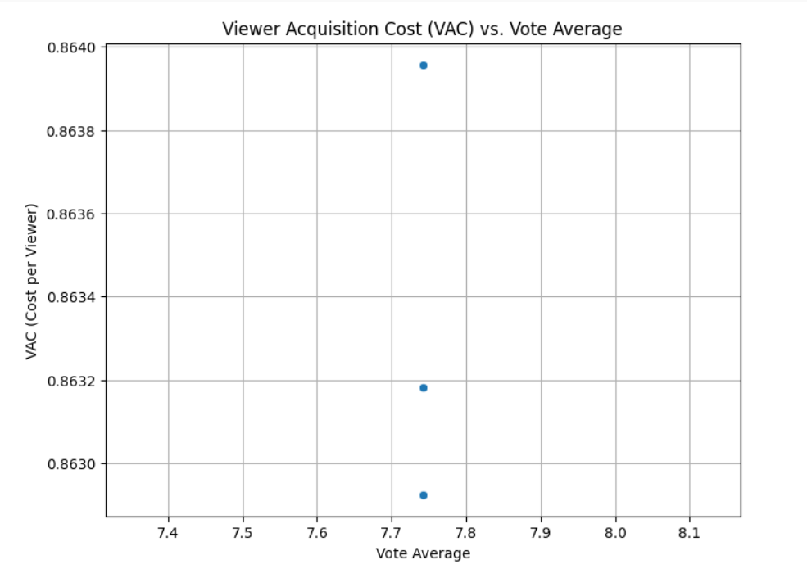

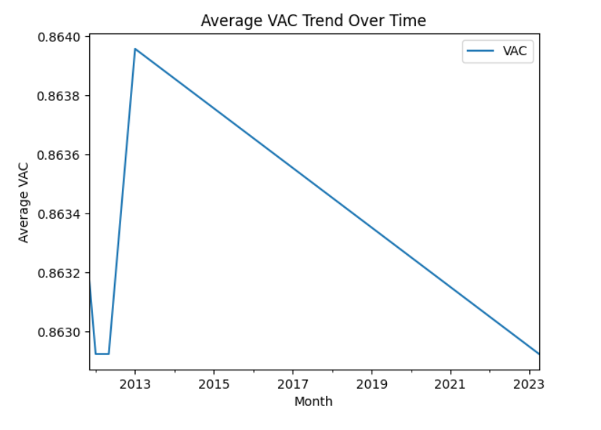

**Progress**

● Accomplishments: Successfully cleaned and preprocessed the VAC dataset. Completed initial trend analysis, identifying key fluctuations in acquisition costs.  
  
● Metrics:  
 - Average VAC for June: $45.60  
 - Maximum VAC recorded in August: $60.20

**Challenges and Solutions**

● Challenges Faced: Missing values in the VAC data affected the continuity of the analysis.  
  
● Solutions Implemented: Imputed missing values using the average VAC for the respective months.

**Next Steps**

● Upcoming Tasks: Complete VAC trend visualization. Compare VAC trends with viewership data to identify correlations.  
● Goals: Generate a detailed report on VAC trends and their potential impact on marketing strategies.

**Conclusion**

● Summary: The analysis of viewer acquisition costs provided valuable insights into monthly fluctuations. Next steps involve finalizing trend visualizations and integrating viewership data to enhance marketing decisions.  
  
● Acknowledgments: Thank you for your attention and consideration of this report.